HCL FINAL HACKATHON
SPRINT - 0 (DESIGN AND ANALYSIS)

Title: Customer Intelligence & Sales Insights Platform using Snowflake

Objective
To leverage customer and transaction data to:
- Understand customer behavior
- Improve sales performance
- Enable data-driven decision making

Data Overview
We used 5 datasets:(SOURCE)
- Customers → profile info
- Products → catalog details
- Orders → transactions
- Order Items → product-level sales
- User Activity → engagement tracking

Target:
1. CUSTOMER_360
2. CUSTOMER_SEGMENTS
3. SALES_INSIGHTS
4. CHURN_ANALYSIS
5. PRODUCT_RECOMMENDATIONS
SCHEMA DIAGRAM:
Logical:
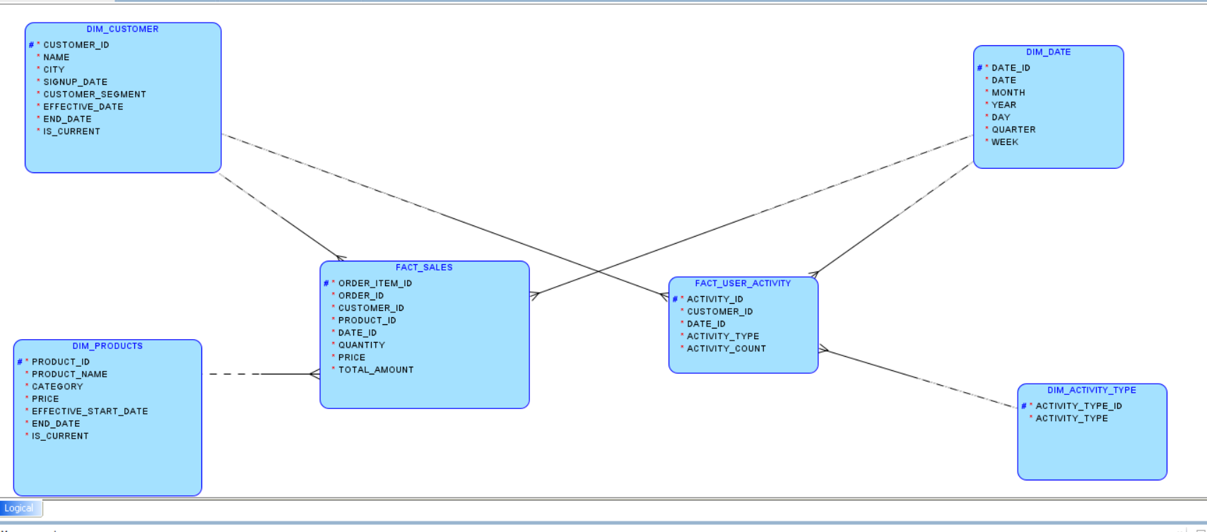
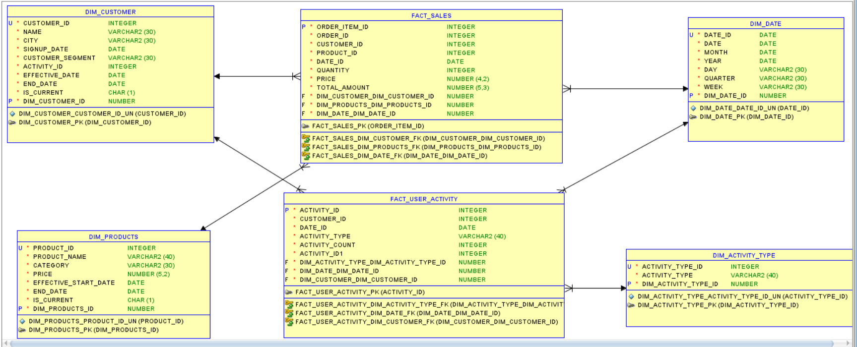
Relational:The relational schema is designed from the dimensional data model, translating facts and dimensions into normalized tables with clear primary and foreign key relationships. It ensures data integrity, supports efficient querying, and provides a scalable foundation for analytical reporting.

Flow Diagram: This flow diagram visually represents the data journey, highlighting ingestion, transformation, and loading stages. It helps in understanding system interactions and ensures transparency in the overall data architecture.
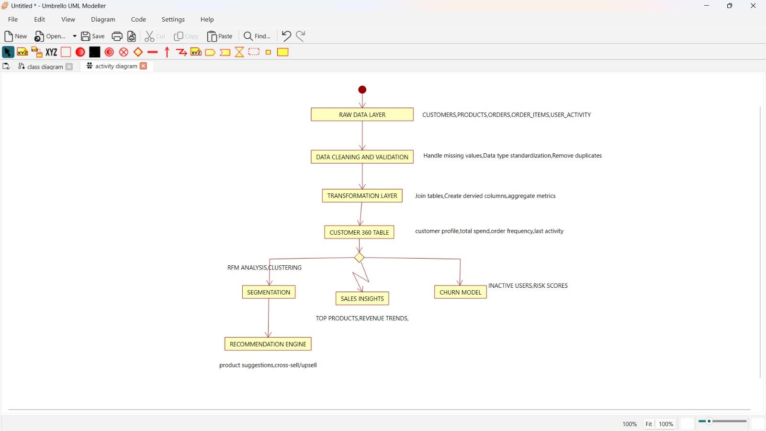

UseCase Diagram: I structured the system into data ingestion, analytics, and business consumption layers, with different actors interacting at each stage to generate insights and drive decisions.
